1. **Demand for water** is **inelastic** because **water** has no close substitutes. **Water** is used for everyday use. It is a necessity.

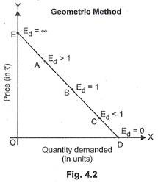

|  |  |  |
| --- | --- | --- |
| Meaning | Giffen goods refer to those goods whose demand goes up with the rise in the prices. | Inferior goods are goods whose demand falls down with the rise in the consumer's income over a specified level. |

3.

1. Inferior Good
2. F=20,000, c=2, n=5

R=(1+i/c)c -1 = 10.25%

P=F/ (1+i)n = 12,278$

2 i)

|  |  |  |  |
| --- | --- | --- | --- |
| * **OUTPUT** | * **AR** | **MR** | **TR** |
| * **1** | * **15** | * **15** | * **15** |
| * **2** | * **13** | * **11** | * **26** |
| * **3** | * **11** | * **7** | * **33** |
| * **4** | * **9** | * **3** | * **36** |

ii)

|  |  |  |
| --- | --- | --- |
| PRICE | QUANTITY | TOTAL EXPENDITURE |
| 7 | 8 | 56 |
| 8 | 7 | 56 |

ED = -1.Here T.E will remain constant.

3 i) ∑Y= Na + b∑X

377= 8a or a = 47.125

∑XY = a∑X + b∑X2

424.5= 42b or b= 10.107

Y(2020) = a +bX

Y(2020) = 47.125 + 10.107 (7.5)= 122.9225

ii)A =$4000  
n =20  
i =6%  
F=?

Please note that n is the number of equal payments.

Using Equation 1-3, we will have  
F =A * F/Ai,n= A[(1+i)n-1]/i  
F =A * F/A6%,20= 4000 * [(1+0.06)20-1]/0.06  
F= 4000 * 36.78559 = 147142.4

So, you will have 147,142.4 dollars at 20th year.

4i) With a fall in the price of tea, the demand of coffee (substitute of tea) decreases. As a result, demand curve of coffee shifts to the left. Accordingly, an equilibrium price would tend to decrease and also an equilibrium quantity tends to decrease.

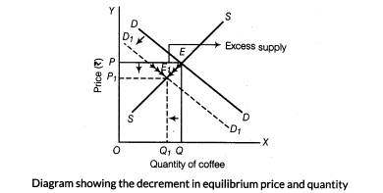

The figure shows a situation of decrease in demand. The demand curve shifts to left side. Consequently, equilibrium price and quantity, both are decreasing from OP to OP1 and OQ to OQ1.

ii) X=20/p+1

dx/dp= -20/(p+1)2  and x=5 when p= 3

ed = 3/4

5i)

|  |  |  |  |  |  |  |
| --- | --- | --- | --- | --- | --- | --- |
| QUANTITY | TU | MU | MU/UNIT | TU | MU | MU/UNIT |
| 1 | **45** | **45** | 15 | **40** | **40** | 20 |
| 2 | **75** | **30** | 10 | **60** | **20** | 10 |
| 3 | **102** | **27** | 9 | **72** | **12** | 6 |
| 4 | **120** | **18** | 6 | **82** | **10** | 5 |
| 5 | **135** | **15** | 5 | **88** | **8** | 4 |
| 6 | **145** | **10** | 3.3 | **90** | **2** | 1 |

ii) 2 BOWLS OF SUGAR + 2 PASTRIES

4 BOWLS OF SUGAR + 3 PASTRIES